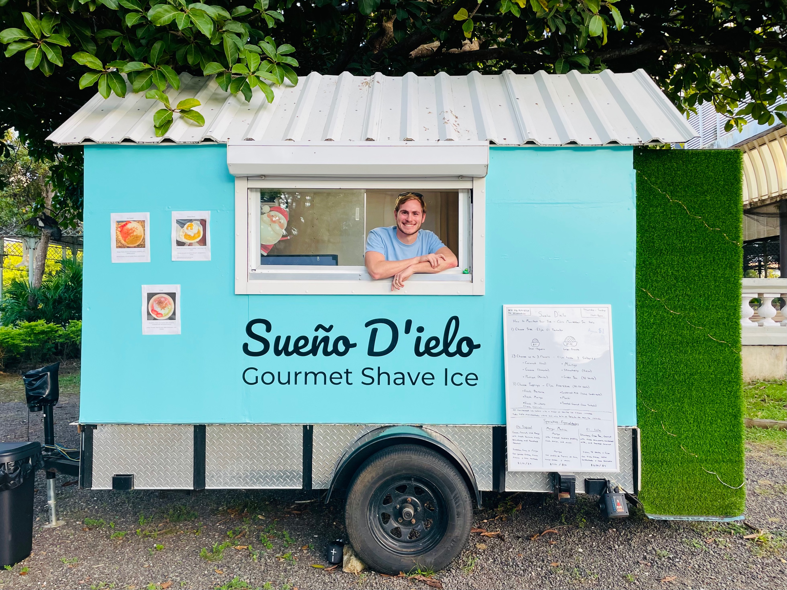

**Schedule**

Sunday 11am-6pm

Monday Closed

Tuesday Closed

Wednesday Closed

Thursday 11am-6pm

Friday 11am-6pm  
Saturday 11am-6pm

Parque Luis Muñoz Rivera between Pabellón de La Paz and C. San Agustín

FW84+4Q9, C. San Agustín, San Juan, 00901, Puerto Rico

Official Website Coming Soon

***Sueño D’ielo Gourmet Shave Ice***